Cracking the Egg: A Look at How the Egg Industry Fooled America

Cholesterol no longer matters, announced the Dietary Guidelines Advisory Committee in February 2015.
In formulating its recommendations for the 2015 Dietary Guidelines for Americans—expected to be released by year-end—the committee held that, contrary to a mountain of scientific research, cholesterol in foods does not increase cholesterol levels in the blood. At long last, cholesterol-laden eggs and sausage could be welcomed back onto menus. Headlines trumpeted the return of cholesterol to the American diet.
The only problem was, it was not true. Neither the public, nor the media, nor most of the committee members themselves realized that cholesterol’s image makeover was, for the most part, an industry-orchestrated effort designed to push Americans into complacency about cholesterol.
The consequences are already apparent. A Gallup poll of 1,009 American adults conducted July 8-12, 2015 (five months after the report’s release) suggested that the public has viewed recent reports that “cholesterol doesn’t matter” to mean that a healthful diet in general does not matter. Gallup’s figures show that, between mid-2014 and mid-2015, the number of Americans seeking to avoid dietary fat dropped from 56 percent to 47 percent. Similarly, far fewer Americans are paying attention to the salt of their foods. In the face of the news that “cholesterol doesn’t matter,” the public has largely decided that food choices in general don’t matter for health.
Cholesterol Matters
Cholesterol is as big a health threat as ever. Eggs are the leading source of dietary cholesterol in the American diet, followed by chicken, beef, and cheese. Apart from their cholesterol-boosting effect, eggs also increase the risk of diabetes. And for people with diabetes, eggs increase the risk of heart problems.
Hundreds of studies over the past half century have shown that dietary cholesterol boosts blood cholesterol levels, and the results were summarized in four meta-analyses between 1992 and 2001.
The effects were especially noticeable when people who habitually avoided cholesterol started adding cholesterol to their diets, for example, by eating an egg or two each day. Their cholesterol levels jumped markedly. For people already consuming cholesterol-laden diets, adding more cholesterol had a less noticeable effect. But overall, the ability of cholesterol in foods to raise blood cholesterol levels was clear.

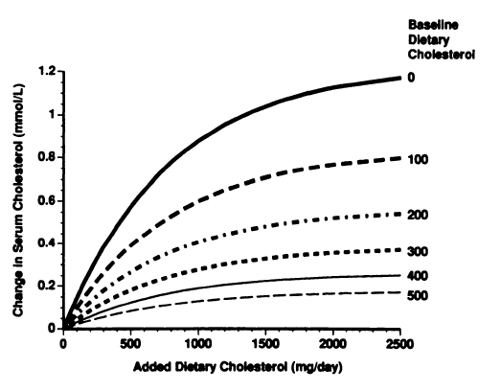
[Figure.] In people consuming no cholesterol to start with (the solid line at the top), adding cholesterol-containing foods causes a marked increase in serum cholesterol levels. For those habitually consuming substantial amounts of cholesterol (lower lines), adding extra cholesterol has less effect. Even so, cholesterol in foods boosts serum cholesterol for all of these groups. (Hopkins PN. Effects of dietary cholesterol on serum cholesterol: a meta-analysis and review. Am J Clin Nutr. 1992;55:1060-1070.)

Industry-Hatched Studies
By the late 1990s, government funding for dietary cholesterol research began to dry up. The scientific issues were largely settled, so there was little point in further research. That is when a different funding source came to the fore. What government-funded researchers had proven, egg-industry-funded researchers aimed to disprove.
Of the 41 studies on dietary cholesterol included in a 1992 meta-analysis, 29 percent had been paid for by industry. Two decades later, in a 2013 review, the figure was 92 percent. In other words, nearly all research on dietary cholesterol is now paid for by the egg industry.
Industry Funding of Dietary Cholesterol Research
1992: 29% 2001: 41% 2013: 92%
The American egg industry’s research and promotion efforts are run by the American Egg Board, famous for its slogan, “The Incredible, Edible Egg,” through the Egg Nutrition Center. Other countries, notably the United Kingdom and Australia, have similar entities that fund research for the purpose of promoting egg consumption.
The Egg Nutrition Center’s plans for research and for the Dietary Guidelines for Americans 2015 were summarized in a Health Professional Advisors Conference Call, June 26, 2013.

Through research grants, the egg industry has established economic relationships with key researchers and major universities. Its studies have worked to portray eggs in a favorable light. Intentionally or not, they have used specific design characteristics to construct research studies that minimize the negative health effects of eggs:
- Method 1: Compare eggs to other high-cholesterol or high-fat foods. Compared to a cholesterol-free egg substitute, eggs raise cholesterol levels. But when researchers compare eggs to meat, this outcome is less likely, because meat has cholesterol and saturated “bad” fat of its own.
- Method 2: Use a mixed diet intervention. When eggs are added to the diet, cholesterol levels tend to rise. But if researchers add eggs while also cutting calories or fat intake, the rise can be blunted, or cholesterol levels can even be made to fall.
- Method 3: Use a small participant sample. Even the most dramatic finding can made to disappear if the subject sample is small enough. If there is more than a 5 percent chance that an observed effect—such as a cholesterol-raising effect of eggs—could be deemed a chance finding, it is generally considered “not statistically significant.” And when that happens, many researchers report there is no effect at all. With very small participant samples, chance findings are much more likely.
- Method 4: Claim that dietary cholesterol affects only certain people. Some industry-funded researchers have divided their research participants into groups, depending on how large their cholesterol elevations were after eating eggs or other cholesterol-containing products, and have suggested that only the “hyper-responders,” are at risk.
When research studies are summarized in published reviews, authors can use another trick or two to minimize cholesterol’s dangers:
- Method 5. Omit older research studies. By limiting their reviews to studies published in recent years—when nearly all studies were industry funded—the results are more favorable than they would be if they had also included older, government-funded studies.
- Method 6. Call positive studies negative, if they are not statistically significant. As noted above, when an effect, such as a rise in cholesterol in response to eating eggs, could have attributed to chance, some researchers mistakenly report there was no effect at all. Reviewers sometimes carry this notion forward in summaries of research findings, suggesting that a great many studies have found no effect.
Oops, Maybe Cholesterol Does Matter After All
In July, the American Journal of Clinical Nutrition published a new meta-analysis showing that dietary cholesterol increases blood cholesterol (the same finding from each of the previous meta-analyses). The accompanying editorial, written by Robert Eckel, M.D., indicated that it was best to be cautious about cholesterol after all.
Physicians Committee experts and members continue to urge the U.S. Department of Agriculture and the Department of Health and Human Services to keep cholesterol warnings in the 2015 Dietary Guidelines for Americans, which are slated for release this winter.

