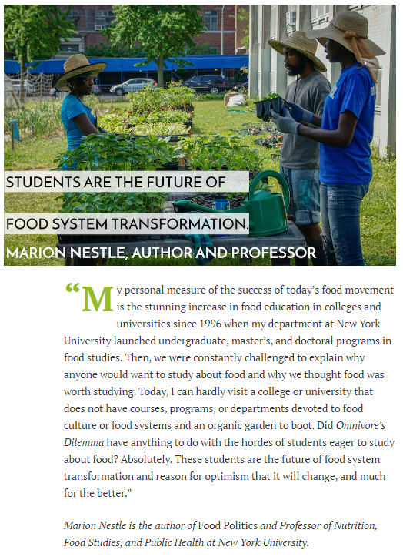

http://newfoodeconomy.com/the-movement-speaks/
June 9, 2016

