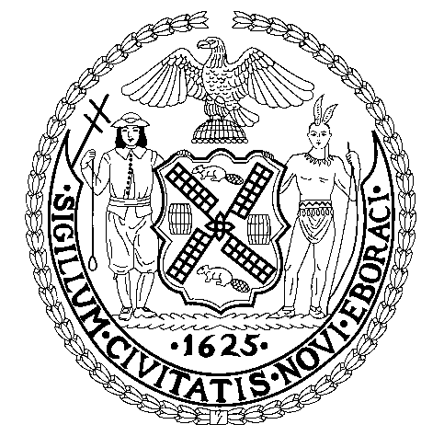

The City of New York

Office of the Mayor

New York, NY 10007

**FOR IMMEDIATE RELEASE**

August 19, 2011

No.301

[www.nyc.gov](http://www.nyc.gov)

**STATEMENT OF MAYOR MICHAEL R. BLOOMBERG ON USDA’S DENIAL OF SUPPLMENTAL NUTRITION ASSISTANCE (SNAP) WAIVER**

*New York City Asked the United States Department of Agriculture to Exclude Sugar-Sweetened Soda from Food Stamp-Eligibility in the Five Boroughs*

“We think our innovative pilot would have done more to protect people from the crippling effects of preventable illnesses like diabetes and obesity than anything being proposed anywhere else in this country **–** and at little or no cost to taxpayers.  We’re disappointed that the Federal Government didn’t agree and sorry that families and children may suffer from their unwillingness to explore our proposal. New York City will continue to pursue new and unconventional ways to combat the health problems that affect New Yorkers and all Americans.”

- 30 -

Contact:          Stu Loeser/Samantha Levine                                       (212) 788-2958

Stay Connected: [Twitter](http://www.twitter.com/nycmayorsoffice)



[Flickr](http://www.flickr.com/photos/nycmayorsoffice/)



[YouTube](http://www.youtube.com/mayorbloomberg)

