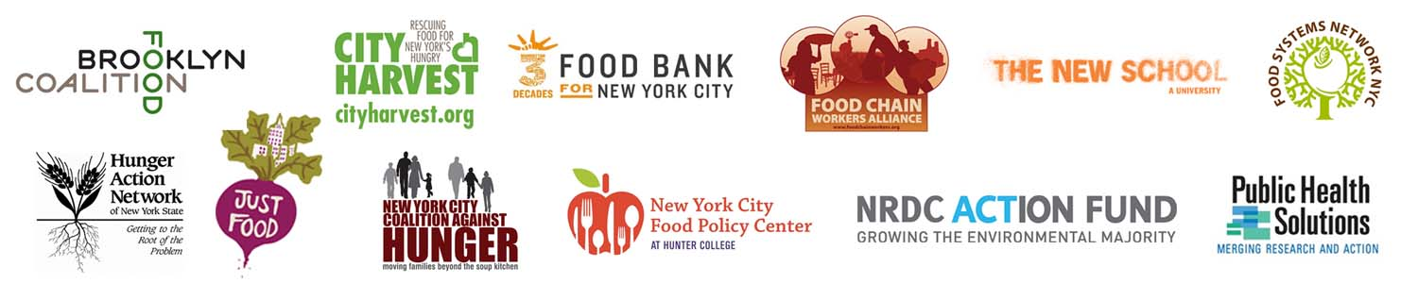
For Immediate Release: Contact: Michelle Friedman
July 17, 2013 212-825-0028 ext. 212
MFriedman@nyccah.org

*** PRESS RELEASE ***

NYC Mayoral Candidates Talk Food, Agriculture, Nutrition & Hunger
at Forum on the Future of Food in NYC

Famed Public Health and Nutrition Expert Moderates

Sold Out Crowd

An unusually large and diverse consortium of groups that work on food systems, hunger, nutrition, and agricultural issues joined together to sponsor one of the highest-profile mayoral candidate forums of the campaign. The forum was aimed at getting the leading candidates for mayor to explain how they would ensure that the city has a healthier, fairer, more sustainable, more affordable, and economically stronger food system. The New School’s Tishman Auditorium, which seats 455, was packed to capacity, as well as the two overflow rooms, which seat 280.

The event was hosted by: Brooklyn Food Coalition, City Harvest, Food Bank For New York City, Food Chain Workers Alliance, Food Studies program at The New School for Public Engagement, Food Systems Network NYC, Hunger Action Network NYS, Just Food, New York City Coalition Against Hunger, New York City Food Policy Center at Hunter College, NRDC Action Fund, and Public Health Solutions.

76 organizations signed-on to support the forum. For the full list visit: http://www.foodsystemsnyc.org/mayoral-candidate-forum-future-of-food-NYC

Marion Nestle, the forum moderator and award-winning author and Paulette Godard Professor in the Department of Nutrition, Food Studies, and Public Health at New York University, said,
“I’m so looking forward to hearing what the mayoral candidates have to say about the food, agriculture, and nutrition issues that we care about so deeply. It’s thrilling that so many organizations got together to produce this event. I hope all the candidates will realize that food issues matter and that food is a vital part of New York City’s economy, society, and culture.”

“City Harvest appreciates the priority that the mayoral candidates are placing on food related issues in our city. With nearly 1 in 4 children coming from a home that has to worry about where their next meal is going to come from, we look forward to partnering with the new mayor on solutions to combat hunger in New York City,” said Jilly Stephens, Executive Director of City Harvest.

“With Congress threatening to make massive cuts to the food stamps (SNAP) program, our next mayor may be forced to address a hunger crisis that will also have economic ramifications across the five boroughs,” said Margarette Purvis, President and CEO of Food Bank For New York City. “These cuts will disproportionately impact the most vulnerable among us and further strain the last strands of the safety net, our city’s emergency food network. Up to 200 million meals could go missing and hundreds of millions of dollars could be lost from the local economy as a result. I applaud the candidates who participated in the Mayoral Forum on the Future of Food in New York City, and I challenge them to both help us prevent these cuts from happening, and to offer our city a plan that ensures no New Yorker goes hungry.”
Diana Robinson, Campaign and Education Coordinator at Food Chain Workers Alliance said, “To truly achieve a sustainable food system in NYC the voices of undeserved communities, the hungry and food workers must be heard. This is the only way we can achieve a just, equitable, and fair food system that benefits all.”
"Access to food is critical to the vitality of any community. The mayoral election provides an important opportunity to expand upon the healthy food reforms the city has already implemented. Unfortunately, many New Yorkers still go hungry while others lack access to healthy food. Food policy can be an economic engine for the city, creating living wage jobs. We should also address hunger among children by mandating the breakfast in the classroom program and adopting free universal school lunches. And we need a Food Policy Council to better coordinate public and private action on our food system," said Mark Dunlea, Executive Director of the Hunger Action Network of NYS.
"Just Food is proud to be a part of this forum which will amplify the voices of everyday New Yorkers," said Just Food Executive Director Jacquie Berger. "As an organization dedicated to building bridges between the grassroots and policy makers, especially those in underserved communities, Just Food applauds the mayoral candidates who are making food system issues a priority."

Joel Berg, Executive Director of the New York City Coalition Against Hunger said, “This mayoral election is critical for the future of New York City’s food system. Anyone who eats - who wants to eat - should care deeply about these issues. We look forward to hearing the candidates’ positions on these vital issues, which impact the life of each and every New Yorker. We especially look forward to hearing if -- and how -- they plan to end the hunger and food insecurity that harm 1.4 million city residents."

“The next Mayor will have an important opportunity to use the power of city government to reduce hunger, food insecurity and diet-related diseases in New York City. Today's Mayoral Candidate Forum on Food Policy will help voters decide how the various candidates plan to use that power,” said Nicholas Freudenberg, Faculty Co-Director, New York City Food Policy Center at Hunter College and Distinguished Professor of Public Health at CUNY School of Public Health.

Heather Taylor-Miesle, Director of NRDC Action Fund, said “There is a massive market for locally and sustainably-grown food in New York City, and it will be up to the next mayor to ensure that all New Yorkers have access to healthy food that’s grown in an environmentally friendly way.”

Arielle Burlett, Neighborhood WIC Program Coordinator for Public Health Solutions, said, “Public Health Solutions is committed to building a healthier New York City by providing opportunities for greater health and food access in our communities. We are pleased to be a co-host of the Mayoral Candidate Forum on Food Policy.”

* The forum Co-Hosts and Partner Organizations and Groups, through their support of this forum, do not endorse nor support or oppose any political candidates or parties.

###

